HOME SCREEN

Exercise #02

Flutter Developer Bootcamp

# **Purpose**

This Exercise creates a home screen for a Flutter application with an app bar containing a title and search button, a scrollable body with sections for promotional banners and featured products displayed in a grid layout..

# **Problem**

The Flutter Exercise creates an e-commerce home screen with an AppBar, promotional banners in a horizontal PageView, and featured products in a grid. This layout provides a clean and engaging interface for users to explore promotions and products.

# **How to Solve**

1. Checkout the workshop from Git Repo:

git clone -b <user-branch> <repo-URL>

2. Open the root folder inside VS Code

3. To build the app click the run option in the main method { }

4. App Bar:

* Contains a blue app bar with a centred title "Home" and a search icon.

5.Body:

* Organised into a scrollable column.
* Contains two sections: promotional banners and featured products.

6.Banner Section:

* Displays a list of promotional banners in a scrollable horizontal layout.

7.Featured Products Section:

* Displays a grid of featured products with their names and images.

# **You Will Achieve**

This Flutter code defines a HomeScreen widget, which represents the main screen of an app. Here's what it achieves:

* AppBar: The Scaffold widget provides a basic layout structure for the screen. The AppBar widget is placed at the top of the screen, featuring a title ("Home") and a search icon button.
* Banner Section: The _buildBannerSection method creates a section for displaying promotional banners. It utilises a PageView.builder widget to display a set of images (banners) in a horizontally scrollable manner.
* Featured Products Section: The _buildFeaturedProductsSection method creates a section for displaying featured products. It uses a GridView.builder widget to display a grid of product cards, each containing an image and the name of the product.

Overall, this code sets up a basic layout for a home screen with promotional banners and featured products, providing a good starting point for further development of an e-commerce or similar application.

# **Screenshots**

## **Expected Output**

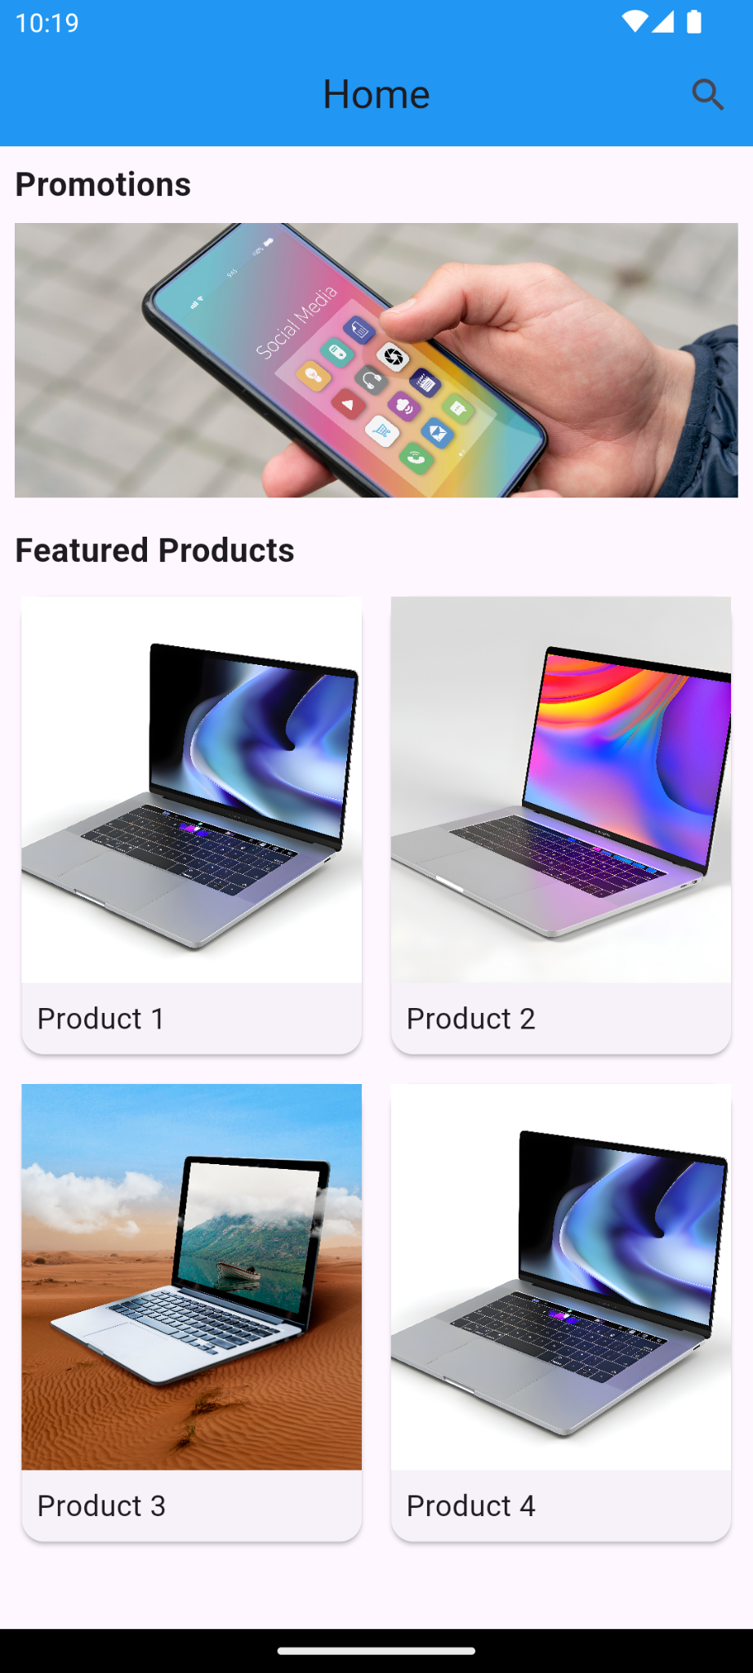 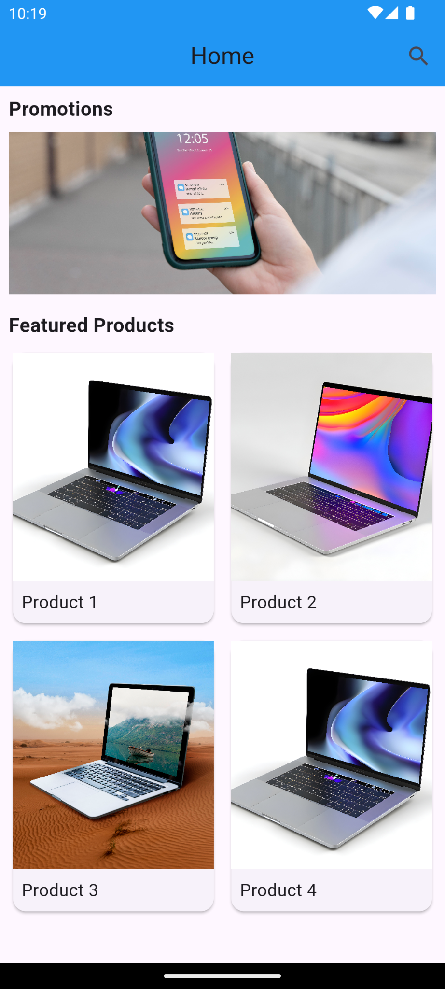 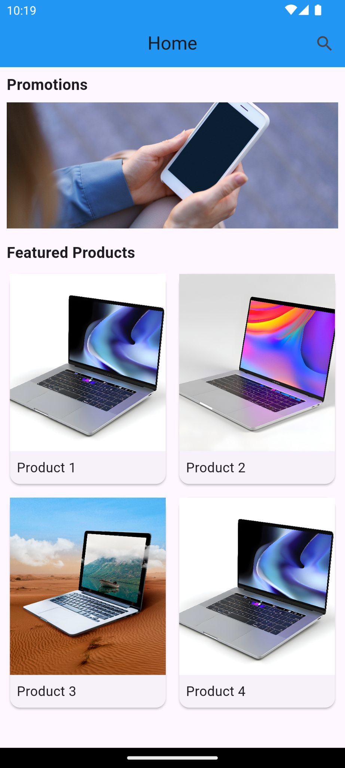

# **How to submit your Exercise**

Push your project back to the same git branch using command:

<command name>

# **Happy Coding!**